RESTRICTED ACCESS: EXPLORATORY PROCEDURES AND OBJECT PROPERTIES

M. Sile O’Modhrain

Center for Computer Research in Music and Acoustics
Stanford University
Stanford, CA 94305, USA
sile@ccrma.stanford.edu

ABSTRACT
In this paper, we present the results of a pilot study that examines whether restricting how people can explore objects haptically effects the object attributes they notice and the efficiency with which they can perform a simple sorting task. 25 observers were each randomly assigned to one of five exploration conditions: two hands (the control), one hand, thumb/forefinger, one finger, or probe. All observers performed a series of two-bin sorts. Stimuli were eight multi-propertied cubes which could be divided into two equal bins according to three properties: size, texture, and compliance. Preliminary results indicate that the restrictions on manual exploration we imposed affected both the exploratory procedures observers chose to use and the efficiency with which they could perform the task. Haptic interface designs
inevitably restrict the exploratory procedures available to the user. This study attempts to determine the cost of these restrictions on the efficiency with which a user can explore multi-propertied objects in a virtual or telepresence environment.

INTRODUCTION
The properties of objects which we perceive via our haptic senses vary according to 1) what we are looking for and 2) what we have access to. If we are searching for juicy oranges at the store, we will test them by weighing them in our hands, but may not pay attention to how round they are. If our hands are cold, we may not be able to discriminate between coins in our pocket according to the knurl on their edges, but we can still sort them by size. The purpose of this study is to discover whether restricting the hand movements that are available during haptic exploration will effect the “efficiency” with which people will perform a two-bin sorting task and the hand movements they employ during sorting. In extracting the haptic properties of objects we are interested in, we employ very specific hand movements, so-called “exploratory procedures” (Lederman and Klatzky, 1987). EPs are stereotypical hand movements which are employed to diagnose a very specific haptic attribute. In judging object compliance, for example, we tend to push on the surface of the object, whereas if we are judging its surface texture, we tend to rub one or more fingers back and forth across its surface. In Table 1, adapted from (Lederman and Klatzky, 1987), we present a summary of the 6 EPs relevant to the present study (since our stimuli are non-functional, we omit two EPs associated with “function testing.” For a complete discussion of EPs, see (Klatzky and Lederman, 1987).
TABLE 1: EXPLORATORY PROCEDURES
EP | Associated Property | Description
Lateral motion | Surface Texture | Induced shear between skin and object
Pressure | Hardness | Force/Torque applied while object is stabilized
Static Contact | Temperature | Contact by large skin surface without effort to mold to contours
Unsupported Holding | Weight | Object is lifted above supportive surface
Enclosure | Shape and Size | Molding to envelop the object
Contour Following | Precise shape | Tracing of edges

TABLE 2: BREADTH OF EFFICIENCY OF EXPLORATORY PROCEDURES.
EP | Texture | Hardness | Volume | Global shape | Exact shape
Lateral Motion | 2 | 1 | 0 | 0 | 0
Pressure | 1 | 2 | 0 | 0 | 0
Static Contact | 1 | 0 | 1 | 1 | 0
Unsupported Holding | 0 | 1 | 1 | 1 | 0
Enclosure | 1 | 1 | 2 | 2 | 0
Contour Following | 1 | 1 | 1 | 1 | 3

In order to discover whether an EP was capable of extracting more than one object property, Klatzky and Lederman conducted a further study in which they asked observers to judge a number of object attributes (e.g. texture, volume, weight, etc.) using only one designated EP. In this way, they were able to rank each EP according to its ability to extract a given property. Thus enclosure, the EP associated with extracting size information, was also found to be useful, though not optimal, for extracting information about object compliance. Table 2 below, adapted from (Lederman and Klatzky, 1990), presents a summary of their findings. In their analysis, Lederman and Klatzky defined an EP as being necessary (a score of 3 in Table 2) if it was the only EP capable of extracting a given object property, optimal (a score of 2) if it was the best of a group of EPs capable of extracting a given property, sufficient (a score of 1) if it was capable but sub-optimal, and “incapable” (0) if an EP was unable to encode the targeted property.
In this study, we extend Klatzky and Lederman's findings by imposing not verbal but physical restrictions on the conditions under which people can interact with objects: physical restrictions which are similar to those imposed by many currently available haptic display devices. Haptic interface designs inevitably restrict the exploratory procedures available to the user. A haptic display which forces one to explore the world with a probe, for example, removes the ability to enclose objects or parts of objects in the hand. Since Enclosure is an EP capable of extracting more than one object attribute (see table 2 above) haptic displays which prohibit its use force the user to fall back on non-optimal EPs for extracting the attributes with which it is associated. Moreover, because a given EP is more efficient at providing information about some attributes over others, the display may also determine the object attributes that are noticed first by the explorer. This study attempts to determine the cost of such restrictions on the efficiency with which a user can explore multi-propertied objects in a virtual or telepresence environment. In our model, a person's interaction with an object is modified by the conditions under which they can explore it. A haptic display which forces one to explore the world with a probe, for example, may not only determine which exploratory procedures might and might not be used but, because a given EP is more efficient at providing information about some attributes over others, the display may also determine the object attributes that are noticed first by the explorer. In other words, the affordances of a given haptic display could affect the exploratory procedures available which in turn might influence the object attributes that are noticed by the user.
In this pilot study, 25 blindfolded observers were each and randomly assigned to one of five exploration conditions: two hands (2H, the control), one hand (1H), thumb/forefinger (1H2F), one finger (1H1F), or probe. All observers performed a series of two-bin sorts. Stimuli were eight multi-propertied cubes which could be divided into two equal bins according to three properties: size, texture and compliance.
Our experiment tested three hypotheses. Firstly, that the most frequently used EPs in sorting by a given attribute would be those considered by Lederman and Klatzky to be “optimal” for extracting that attribute. Thus, in sorting by compliance, observers would use more pressure EPs than any others. Likewise, in sorting by texture, observers would use more Lateral Motion EPs than any other. In the case of size (volume), we hypothesized that Enclosure would be the most frequently used EP in the 2H, 1H and 2F conditions but that in the 1F condition static contact and contour following, both of which are "sufficient" for extracting size information, would be used in place of enclosure, and in the probe condition, contour following alone would be used. Table 3 summarizes the EPs which we predicted would be used most often in each exploration condition.
Our second hypothesis was that in sorting by size, observers would be more "efficient" in the 2H, 1H and 2F conditions than in 1F or Probe, because 1F and Probe have to rely on non-optimal EPs since Enclosure is not available. Our final hypothesis relates to what Klatzky and Lederman refer to as “Modality-encoding Bias” (Lederman and Klatzky, 1996). Lederman and Klatzky's study showed that when biased toward haptic processing, people sorted most often by material variation determined by variations in texture, hardness (1987) or in weight and thermal properties (1996), whereas when permitted vision, they sorted most frequently by geometric properties, determined by shape and size. Based on this, we hypothesized that, given no other directions than to sort blocks into two equal bins, blindfolded observers would choose to sort first by material properties such as compliance and texture and only secondly by size.

EXPERIMENT

Method

Observers
25 volunteers, 14 male and 11 female, participated. Observers were recruited from the students, staff and faculty at Stanford's Center for Computer Research in Music and Acoustics (CCRMA). Four were left-handed and all were naive as to the purpose of the experiment. The group ranged in age between 20 and 72, with a mean age of 31.
TABLE 3: PREDICTED EPs
Condition | Sort dimension | Predicted EP
2H | Size | Enclosure
1H | Size | Enclosure
1H2F | Size | Enclosure
1H1F | Size | Static Contact & Contour Following
Probe | Size | Contour Following
2H | Compliance | Pressure
1H | Compliance | Pressure
1H2F | Compliance | Pressure
1H1F | Compliance | Pressure
Probe | Compliance | Pressure
2H | Texture | Lateral Motion
1H | Texture | Lateral Motion
1H2F | Texture | Lateral Motion
1H1F | Texture | Lateral Motion
Probe | Texture | Lateral Motion

Stimuli
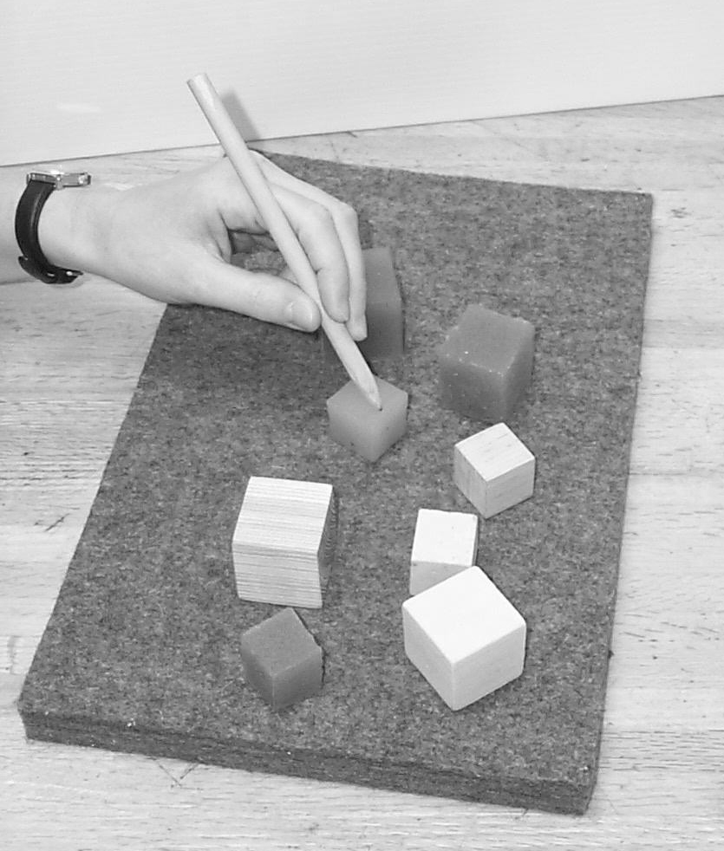

Figure 1. An observer is exploring the stimuli (8 multi-propertied blocks) using a probe.
Our stimuli were 8 multi-propertied cubic blocks. Three dimensions, size (large/small), compliance (hard/soft) and surface texture (rough/smooth) were fully crossed. In this initial stimulus set, no attempt was made to psychophysically equate values on the three dimensions used - the blocks were simply designed to be easily sorted into two equal groups according to each of the three dimensions. Table 4 shows the distribution of properties across blocks and the materials we used to construct them.

Procedure
At the beginning of an observation period, each observer was blindfolded and seated before a table. They were told that, on a felt pad on the table in front of them, there were 8 blocks which differed from each other in a number of ways. They were then asked to sort the blocks into two groups, placing one to their right and the other to their left and to place their hand(s), palm(s) upward on the table in front of them when they were finished. At the end of the first sort, the observer was asked which dimension he/she had chosen to sort along and was asked to pick another feature and perform another sort. This procedure was repeated until the observer had completed three sorts. At the end of the experiment, each observer was also asked to demonstrate what hand motions they used to test for their selected property in each sort. The entire session was video taped for later analysis.
For the two- and one-finger sort conditions, an elastic cuff was placed on the preferred sort hand to keep all other fingers out of the way. In the probe condition (Figure 1), the observer was given a wooden dowel, 17 cm long, 8 mm in diameter and pared to a blunt tip at one end. The tip of the probe, measured with calipers, was 1.2 mm in diameter. However, the actual contact diameter when the probe is pressed against a surface may be different due to pressure and contact angle. To estimated this, we inked the tip of the probe and took the average size of ten imprints on a stack of paper. This resulted in an estimated contact diameter of 1.3 mm.
TABLE 4: STIMULI
Block | Description | Size (cm³) | Materials used
1 | small smooth soft | 1.5 | smooth-sided mold and Urethane RTV
2 | small rough soft | 1.5 | sandpaper-lined mold and Urethane RTV 3
3 | large smooth soft | 2.5 | smooth-sided mold and Urethane RTV
4 | large rough soft | 2.5 | sandpaper-lined mold and Urethane RTV
5 | small smooth hard | 1.5 | sanded pine
6 | small rough hard | 1.5 | hard yellow foam
7 | large smooth hard | 2.5 | sanded pine
8 | large rough hard | 2.5 | hard yellow foam

Results

Analysis of Exploratory Procedures
To see whether certain EPs were indeed more likely to be used in certain conditions and certain sorts, we recorded the number of occurrences of each EP in each condition from the video tapes of our observers' sorts. These data are presented in Figure 2. The three graphs show the number of occurrences of each EP for each experimental condition for size, compliance and texture sorts respectively. In each graph, the number of occurrences of each EP is given by values on the Y axis while the bins along the X axis represent each experimental condition. Note: Hand movements used simply to hold the object in place during or between EPs were ignored in this analysis. Because the number of observers in each experimental condition in our pilot study was so small (five per group) it is not possible to say whether the number of occurrences of a given EP in a given condition is truly representative of its use by all observers in that condition.
Therefore, in order to see if “optimal” EPs would occur most often when that property was the property targeted for a sort, we modeled whether or not the “optimal” EP was actually the most frequently used, for each of the 5 observers, as a Bernoulli(5,p) process (where “success” means that the “optimal” EP was the most frequently used by a observer, “failure” means that EP was not the most frequently used). We considered the null hypothesis to be that the “optimal” EP was no more likely to be chosen than some other EP, i.e. that p₀ = 0.5 (compared against the alternative hypothesis that p > 0.5). For each condition and sort dimension, the predicted “optimal” EP, the number of successes by the above definition, and the p-value are tabulated in Table 5.
For the size sort, the number of occurrences of the enclosure EP was statistically significant for the 2H condition (p = 0.0312). For 1H1F and Probe, though, the predicted EPs were not those used by the observers (Static Contact and Contour Following were rarely used in the 1H1F condition and Contour Following was never used in the Probe condition.)
Our results for the Compliance sort are more equivocal. Only in the 1H2F condition was the use of pressure statistically significant (p = 0.0312). For texture, the use of Lateral Motion was statistically significant for the 1H and 1H1F conditions (p = 0.0312 for both 1H and 1H1F). Finally, because only one observer in the probe condition completed a texture sort, this cell was not included in our EP analysis.
Figure 2. EP occurrence by sort condition.

Figure 3. Mean efficiency scores by condition and sort

Efficiency Scores
To test our second experimental hypothesis - namely that the EPs available under some conditions made these conditions more “efficient” than others, we timed the duration of each sort and recorded the number of misplaced blocks at the end of the sort. We used these data to calculate an “efficiency” score for each sort using the following formula:

Efficiency score = (% of correctly placed blocks) / (sort time)

Thus our efficiency score is both a measure of accuracy and the time taken to perform the sort. In Figure 3, the efficiency is plotted by sort for each condition. (Note: Lower scores
here indicate greater efficiency because the time taken to complete the task was less and no blocks were misplaced.)
Specifically, we tested whether the presence or absence of the
enclosure EP had an effect on the efficiency of sorting by size.
We used our efficiency score to conduct an independent samples t_ test, where we compared 2H 1H and 1H2F against 1H1F and Probe conditions. The test was significant, t (23) = 3.95, p = .001. Observers in the 2H, 1H and 1H2F conditions had a lower mean efficiency score (M = 44.53, SD = 31.00) than those in the 1H1F and Probe conditions (M = 12.60, SD= 64.85.) Thus the lack of access to enclosure (the EP predicted to be optimal for extracting size) had a significant effect on the efficiency with which observers could perform size sorts in 1H1F and probe conditions.

Analysis of sort order
Our final experimental hypothesis was that, based
on Lederman and Klatzky's assertion (namely that touch is more efficient at extracting material properties than geometric properties), given no directions other than to sort blocks into two equal bins by whatever attribute they wished, observers would choose to sort blocks by their material properties (in our case compliance and surface roughness) before they would sort by geometric properties (in our case, volume, since our stimuli were all cubes). To test this hypothesis, we again modeled whether compliance and texture would be chosen before size as a Bernoulli(5,p) process, (where “success” means that either compliance or texture were chosen first by each observer, and “failure” means that they were not.) We considered the null hypothesis to be that material properties would be no more likely to be chosen than geometric properties, i.e. that p = .5. Only the 1H2F and Probe conditions produced statistically significant results (p = 0.0312 in both cases.)
TABLE 5
Cond-ition | Sort dimension | Predicted Optimal EP | Number of Successes | p-value
2H | Size | EN | 5 | 0.0312
1H | Size | EN | 4 | 0.1875
1H2F | Size | EN | 4 | 0.1875
1H1F | Size | SC & CF | 1 | 0.9687
Probe | Size | CF | 0 | 1.0
2H | Compliance | PR | 3 | 0.5
1H | Compliance | PR | 2 | 0.8125
1H2F | Compliance | PR | 5 | 0.0312
1H1F | Compliance | PR | 3 | 0.5
Probe | Compliance | PR | 2 | 0.8125
2H | Texture | LM | 3 | 0.5
1H | Texture | LM | 5 | 0.0312
1H2F | Texture | LM | 3 | 0.5
1H1F | Texture | LM | 5 | 0.0312
Probe | Texture | LM | No Data

DISCUSSION

The most enlightening results to emerge from this preliminary data concern the use of exploratory procedures. In sorting by size, observers in 1H1F and Probe conditions, where enclosure (the optimal EP for judging size) was not available, observers did not fall back on static contact and contour following, both of which Lederman and Klatzky had defined as being sufficient for extracting size information. Instead, observers used an entirely different EP, which we classified as “tapping” (see Figure 2), where they touched lightly on the tops of blocks, comparing their relative heights. Because of the assistance from an external supporting surface, the table, this EP could be considered to be a form of enclosure. It was interesting to note that even though it was possible for observers to rest their arm on the table, and hence have an external reference, none of the observers chose to do this when tapping. Therefore, it is necessary to exercise some caution in making a direct comparison between tapping and normal enclosure because the chain of receptors involved in making height judgments by tapping (i.e. those in the elbow and shoulder) are not as sensitive to small changes in joint angle as those in the hand (Tan, et al., 1994).
For Compliance sorts the predicted EP, Pressure, was significant in 1H2F (p = 0.0312), but not in other experimental conditions. In the Probe condition, 3 out of 5 observers used a tapping EP. When asked why, they said they were using the difference in sound between tapping on rubber and on wood/foam to sort the blocks. Even though the pressure EP was available, these observers found that it was easier to use feedback from a second sensory modality, hearing, to judge the relative hardness of the stimuli. As previous investigators have shown (Durst and Krotkov, 1995), it is possible to classify objects from impact acoustics. Anecdotally at least, this suggests that when access to haptic cues is severely restricted, auditory cues normally redundant may come to play a more important role in judging material properties of objects.
As can be seen by the efficiency scores for the texture sort in Figure 3, most observers found it difficult to sort our stimuli by texture. Two observers said that they sorted blocks by hardness according to whether the surface was “sticky” or not, indicating that our choice of materials confounded material cues with surface roughness cues. Our hard rough blocks, which were made of hard yellow foam, had a slightly gritty feel while our soft rough blocks, made by pouring Urethane RTV into a sandpaper-lined mold, had a dimpled feel. The fact that only one observer in the probe condition even attempted to sort by texture would suggest that the absence of cutaneous cues and hence the reliance on vibration cues, only served to amplify this confound. Moreover, In 1H1F and Probe conditions, observer's attempts to use a lateral motion EP often caused the blocks to rock and sometimes flip. This made it difficult for observers to maintain contact with the surface of the blocks, particularly for the rubber blocks whose surface was slightly sticky. In future studies, securing the blocks to the table should make it possible to use lateral motion to extract texture information and hence make it easier for observers in these conditions to complete texture sorts.
The material/texture confound in our stimuli also made it difficult to draw firm conclusions about the effect of restricting exploration conditions on modality-encoding biases. Because we made no attempt to psychophysically assess the discriminability of the blocks along each of the dimensions we were interested in - size/volume, compliance and surface roughness - we were unable to use sort order as a measure of whether people would sort first by material or geometric properties. We are currently redesigning our stimuli in order to remove this confound.
One way to test whether restricting the hand movements available during haptic exploration impacts people's ability to apprehend a given object attribute is to identify an exploratory procedure that is not available under all exploration conditions.
Then we can compare the efficiency of sorts by the attribute associated with an EP in conditions where that EP is available and in conditions where it is not. For our combination of object attributes and exploration conditions, the only EP which we could test in this way was Enclosure, the EP which is optimal for making size/volume judgments. (Pressure and Lateral motion EPs, those associated with compliance and texture, are available under all exploration conditions tested in this study.) If Enclosure was not available, as in the 1H1F and Probe conditions, then a non-optimal EP would need to be pressed into service instead. Our results clearly indicate that having to fall back on non-optimal EPs reduces the efficiency with which this task can be performed. From this finding we can infer that: 1) When the restrictions imposed on haptic exploration eliminate an EP, the object attribute it is diagnostic of may still be accessible but it will be less efficiently extracted, and 2) Given a set of constraints on exploration imposed by, say, a haptic display device, it should be possible to predict which object attributes can be extracted and what the cost of the constraints will be in terms of efficiency.

CONCLUSIONS AND FUTURE WORK

Even though our sample size was small (5 observers per condition), we were able to demonstrate two results: Firstly, the lack of access to optimal exploratory procedures for observers in the 1H1F and probe conditions had a marked effect on how efficiently they were able to sort objects by size. Secondly, when optimal EPs were not available, observers tended to develop alternative strategies to judge object properties, rather than fall back on non-optimal but sufficient exploratory procedures.
In order to expand this study, we are redesigning our stimuli to ensure that they are perceptually equivalent along the three dimensions we are testing - size/volume, compliance and surface texture. If these properties are truly psychophysically equated, then we will be able to test both how accessible a given property is under a given condition and whether the restrictions we impose effect which attributes of multi-propertied objects are most salient for that condition. If certain exploration conditions result in one attribute of a real object having more perceptual prominence than another, then it is reasonable to assume that this will be true for multi-propertied objects in a virtual environment as well.

ACKNOWLEDGEMENTS

The author wishes to thank Allison Okamura for her considerable help in preparing the stimuli for this study, Kristin Precoda for help with statistical analyses and Susan Lederman for permission to use the detailed EP scoring rules defined by Lederman, Klatzky et al for their studies of Exploratory Procedures.

REFERENCES

R.S. Durst and E.P. Krotkov, “Object classification from analysis on impact acoustics,” in Proceedings for the IEEE/RSJ International Conference on Intelligent Robots and Systems, Vol. 1, pp. 90-95, 1995.

R.L. Klatzky, et al., “There's more to touch than meets the eye: The salience of object attributes for haptics with and without vision,” in Journal of Experimental Psychology: General, Vol. 116, No. 4, pp. 356-369, 1987.

R.L. Klatzky and S.J. Lederman, “Stages of manual exploration in haptic object identification,” in Perception and Psychophysics, Vol. 52, No. 6, pp. 661-670, 1992.

S.J. Lederman and R.L. Klatzky, “Hand movements: A
window into haptic object recognition,” in Cognitive Psychology, Vol. 19, No. 3, pp. 342-368, 1987.

S.J. Lederman and R.L. Klatzky, “Flexible exploration by human and robotic haptic systems,” in Proceedings of the 12th Annual International Conference of the IEEE/Engineering in Medicine and Biology Society, Vol. 12, No. 5, 1990.

S.J. Lederman, C. Summers, and R.L. Klatzky, “Cognitive Salience of Haptic Object Properties: Role of Modality-encoding bias,” in Perception, Vol. 25, No.8, pp. 983-998, 1996.

H.Z. Tan., “Human factors for the design of force-reflecting haptic interfaces,” in Proceedings of the ASME WAM, DSC, Vol. 55, No. 1, pp. 353-360, 1994.

The classification of EPs from the recordings made during experimental trials was performed according to the scoring rules devised by Lederman and Klatzky for their studies of Exploratory Procedures (Lederman and Klatzky 1987, Klatzky and Lederman 1987, Lederman, Summers and Klatzky 1996), specific details of which were obtained from the authors.

